Public CMS V4.0

Deplyment Manual
目录
One. Introduction to Public CMS 1
1. Profile 1
2. Lisence Agreement 1
3. Access to Public CMS 1
4. Directories 2
5. Deployments 2
6. Operating Environment 5
7. Deployment Steps 5
Two. Multi-site Configuration 7
1. Parsing the domain name 7
2. Adding new websites 7
3. Visiting new websites 8
4. Design your website 8
Three. Support service 9
1. Free service 9

Introduction to Public CMS

Profile
The Public CMS is designed based on the latest 2022 Java technology with open source code and frindly structure to SEO. Public CMS can operate/manage hundreds of thousands data and PV easily. Public CMS has been accepted and used by many famous companies and enterprises, and it owns a total of 0.0002% of the total websites of the world. We provide free version and technology support , and we believe Public CMS will be a good choice for great data website construction and big enterprise projects.
- Public CMS is suitable for both dynamic website and static website;
- Public CMS can support multi-site creation, with totally separate data and template for each website.

Lisence Agreement
- Authorised rights
  - Modify ,Copy and share Public CMS and its source code;
  - Get license agreement free meeting all prerequisite conditions, and use Public CMS in non-business conditions ( individual only);
  - Application of Public CMS in business usage for at most 3 months, during which time, the Public CMS logo and license agreement must appear in an obvious position of the website.
  - Licensed users can Modify ,Copy and spread Public CMS and its source code and the product s and their source codes;
  - The license agreement applys only to V4 of the Public CMS, earlier versions have their own license agreement;
- Copyright
  - The copyright of the software belongs to Public CMS;
- Disclaimer (of warranty)
  - Public CMS and its affiliated documents are not responsible for any possible risk caused, and won`t give any kind of compensation. Public CMS is without warranties OR CONDITIONS OF ANY KIND, either express or implied;
  - Before using Public CMS, one should fully understand it and assume its possible risk. We won`t provide any technology support unless you buy the service.

Access to Public CMS
Public CMS source code:
GITEE: https://gitee.com/sanluan/PublicCMS
GITHUB: https://github.com/sanluan/PublicCMS

Directories
data/publiccms
publiccms-parent

- data/publiccms` s sub- directories:
Indexes: Full-text search engine, automaticly created by the system;
Task: Script for task plan
Template: Directories for templates
Web: Directories for static website and resource documents
- publiccms is an excecutable program, whose codes can be operated by J2EE website container or java –jar publiccms.war.

Deployments
Public CMS has many different ways of Deployments which can meet different needs. Option 1 is more preferable while option 2 &3 is only suitable for dynamic web container such as tomcat, which will cause a lot of resource waste when being used to deal with static resources;
Deployment Option 1
To use dynamic and static function, you are to use tomcat web container together with nginx. Nginx can provide reverse proxy, resource file, visiting to static website , and SSI support to dynamic and static request;
Deployment Option 2
To use dynamic and static function, you can only choose to use tomcat web container. The static function is optional
Deployment Option 3
Deploying Public CMS by Spring Boot, adding flushbonading website container like Tomcat before start Public CMS . Deployment Option 3 can also be done together with the support of Nginx.
Deployment Option 4
Find someone who is familiar with Public CMS to help you.

Deployment Option 1
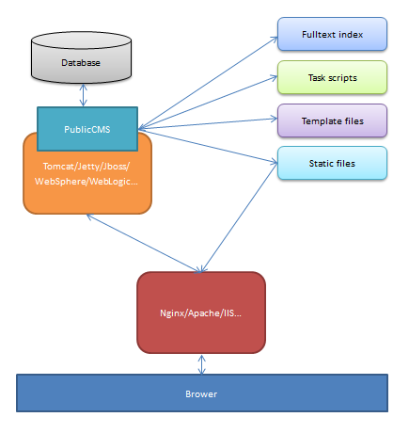
Public CMS runs in web containers like Tomcat which can support Servlet3.0, and Template files, static files, full-text indexes are reserved independently in server disk. Static files published by HTTP service, provide access to resource files like website or picture. The web container of Public CMS provides reverse proxy through HTTP Service program, and provide Background management interface and dynamic web visiting.

Deployment Option 2
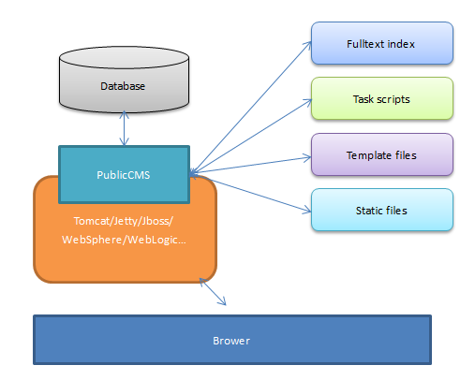
Public CMS runs in web containers like Tomcat which can support Servlet3.0, and provide Background management interface and dynamic web visiting. Static files are can provide web and picture visiting through Public CMS.

Deployment Option 3
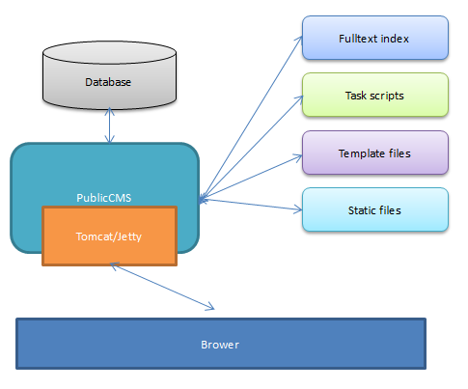
Public CMS are activate through Embedded container, and provide background management interface and dynamic web visiting

Operating Environment
Public CMS Operating Deployment
  - Required softwares
jre8+ (http://www.oracle.com/technetwork/java/javaee/downloads/index.html)
Mysql5.0+ (http://dev.mysql.com/downloads/mysql)
  - optional softwares
nginx(http://nginx.org/en/download.html)/apache (http://httpd.apache.org/download.cgi)/IIS
tomcat8.0+(http://tomcat.apache.org/)/jetty8.0+(http://www.eclipse.org/jetty/downloads.php)
Please choose web containers like tomcat，jetty when deploying Public CMS in a traditional way.

Deployment Steps
Take Deployment option 1 for an example.

Project configuration
Project configuration files are under the directories of WEB-INF/classes
cms.properties are configuration files for CMS

Configurations | Discription | Remarks
cms.filePath | Absolute path for CMS data directory
cms.masterSiteIds | Mmanagement website ID | different ID should be separated by a half-angle comma
cms.defaultSiteId | Default website ID
cms.tokenizerFactory | Default Tokenizer : hmmchinese | keyword,letter,lowercase, whitespace,edgengram, ngram, pathhierarchy, pattern, classic,standard, ax29urlemail, thai, wikipedia, hmmchinese
cms.task.threadCount | Task scheduling thread count
cms.multipart.maxUploadSize | Maxmium for uploaded files
The cms.filePath in Configurations column can be configurated by Dcms.filePath parameter.

Deployment of Public CMS
Put the war files under the “webapps” directory of the container, and then start the container.

Initialiazation data
If there are no install.lock under the data directory or the configuration is wrong, the installment interface will be popped-up by default after visiting the program. Fill the information of the data base , and choose to initialize or update data base. You can also initialize or update data base manually later.
The initialization script of the data base is under the “WEB-INF/classes/initialization/sql/” directory; data base updating script is under the ”WEB-INF/classes/initialization/upgrade/ “directory;

Visiting Public CMS
Please visit the route of Public CMS published through tomcat.

Configuration of Nginx
click website、website management, and get the nginx configuration under each configuration model of each website.

Multi-site Configuration

Parsing the domain name
First Resolve the domain name of your new website to the sever of Public CMS, consulting the domain name register service provider for the resolving method and sever operation and maintenance staff for server IP.

Adding new websites
Login the background management interface of Public CMS. Fill in the website information, save it. Please remember your management username and password.
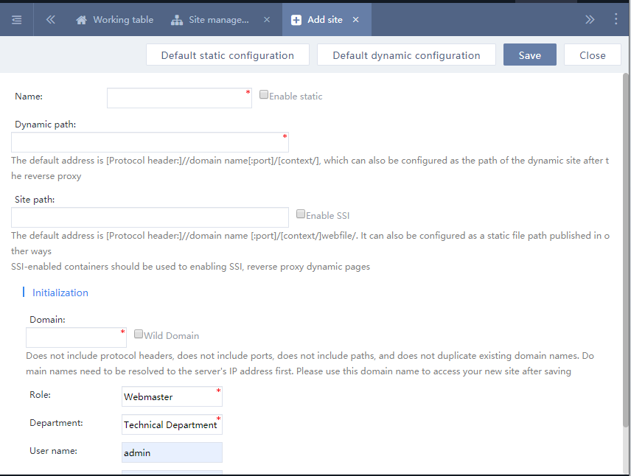

Visiting new websites
Visit the new website using the same domain name above, and use the same management username and password to log in and manage the new website.
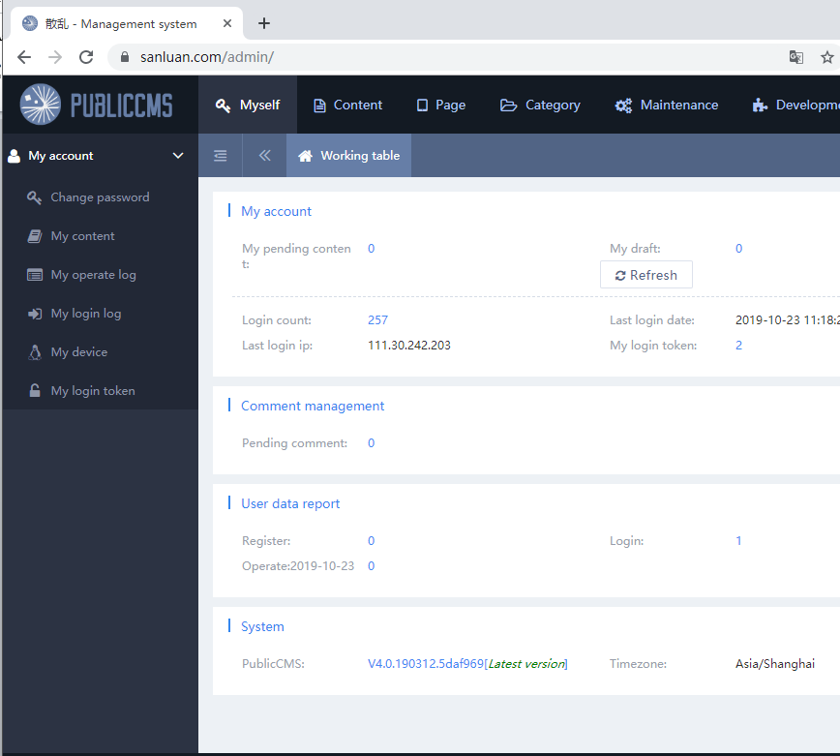

Design your website
Newly created websites are blank, and 404 will be present when you visit such websites. Visit the background interface to create Templates, categories, content models, content . Please refer to the Template creating manual.

Support service

Free service
Public CMS Official website:https://www.publiccms.com/
QQ Group:191381542 , 481589563 , 638756883
Freemarker Manual :http://www.kerneler.com/freemarker2.3.23/
Debug FreeMarker online：https://www.sanluan.com/freemarker_test.html

